

Code-Layout, Readability and Reusability

Date | 2 July 2026
Team ID | SWUID2026213859
Project Name | Rising Waters
Maximum Marks | 5 Marks

Code-Layout, Readability and Reusability:
This document evaluates the quality of the codebase in terms of its structure, readability, and reusability. Well-organized code with proper naming conventions, comments, and modular design ensures that the project is maintainable and can be extended or reused in future development.

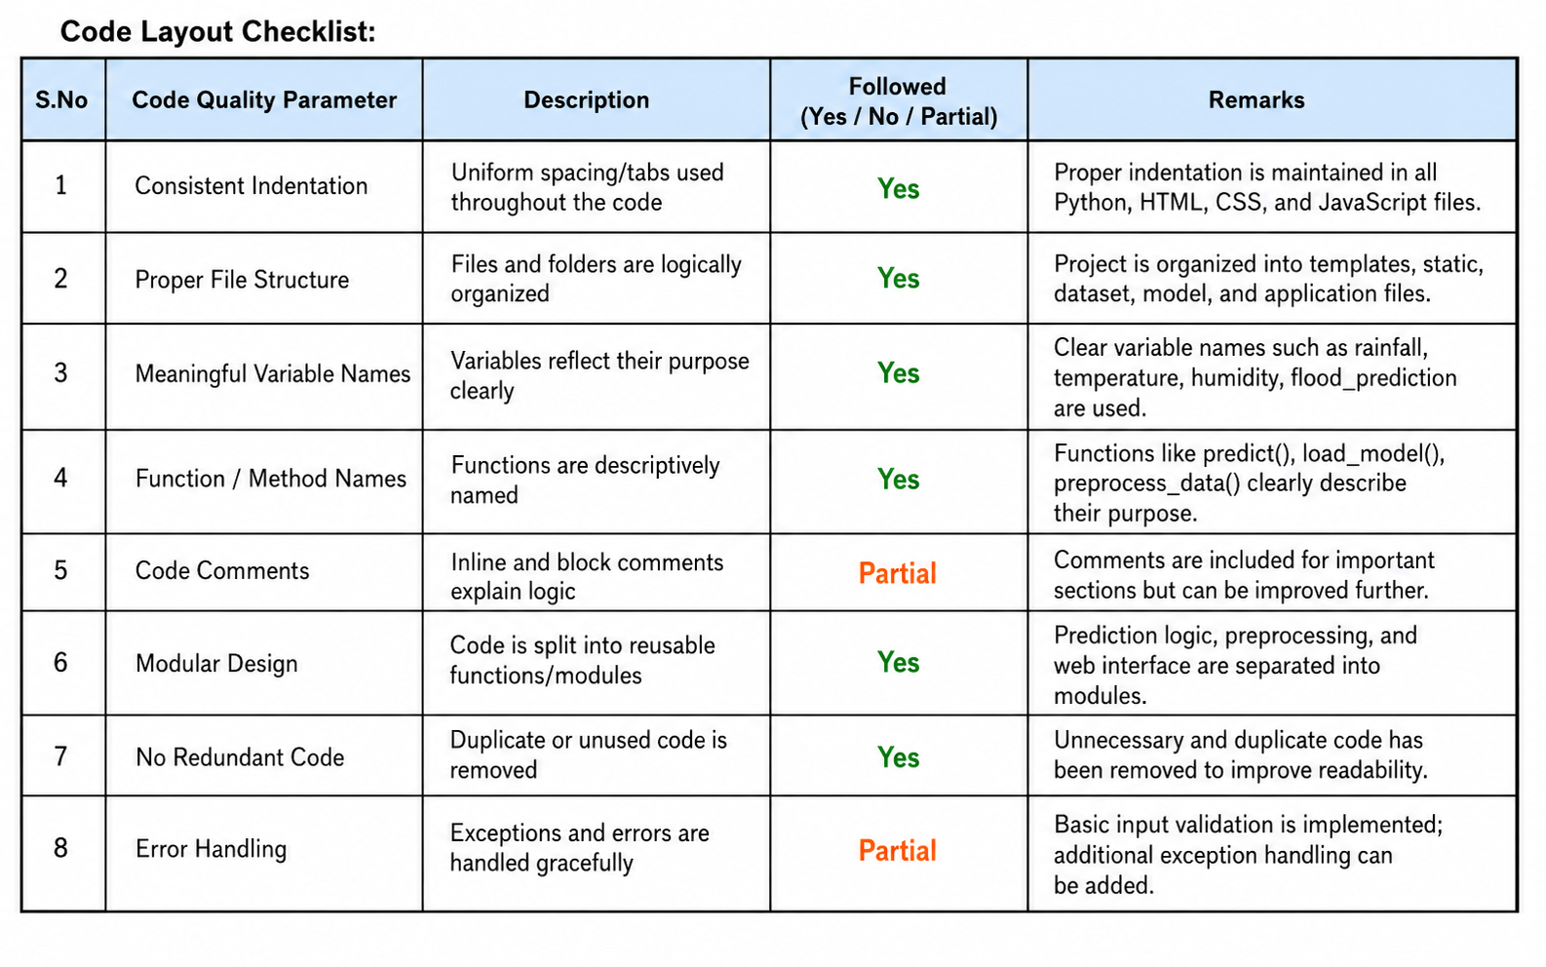

Reusable Components / Modules:

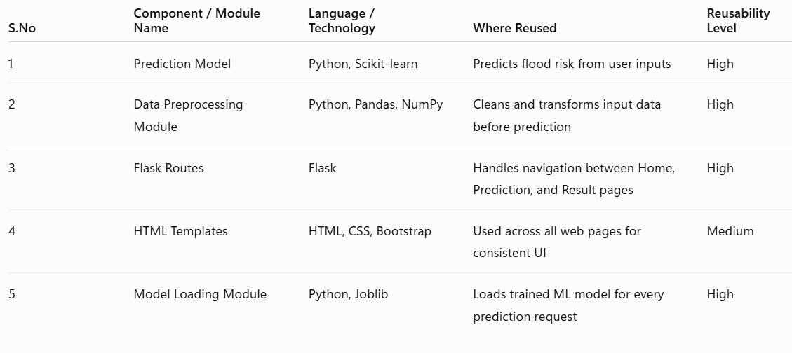

Overall Code Quality Assessment:
